**Create a document to do sprint planning**

* ***Why we need to do sprint planning?***
* Sprint planning is to define what can be delivered in the sprint and how that work will be achieved.

**Example:**

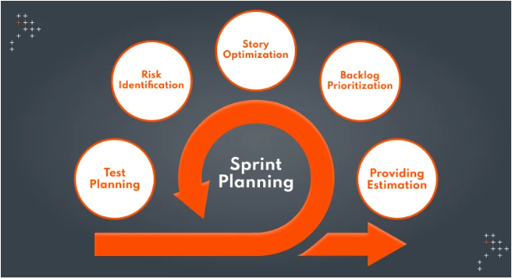

**We have question three in ask:**

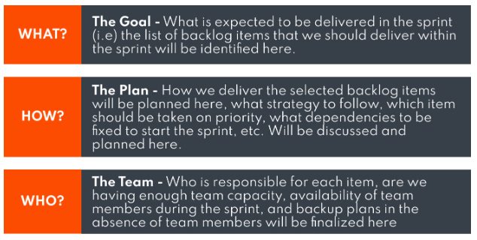

* Why do we need to do a stand-up meeting?
* Stand-up meetings are quick sessions that last 15 minutes or less. Their main agenda is to get daily updates on team members’ progress, plans, and obstacles.

We have questions to ask in team:

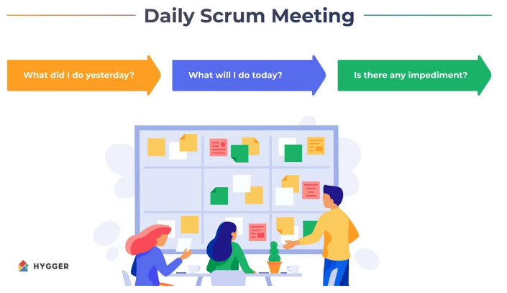

* Why we need to do sprint retrospective?
* Sprint Retrospective is to identify potential pitfalls and mistakes, evaluate the past working cycle, and define actions that may improve things.

We have questions to ask in team:

* What are you doing well?
* What should we change?
* How should we solution?
* Why we need to do sprint review?
* Sprint review enables the team to collect feedback on the work items that have been completed during a sprint.

**Example:**

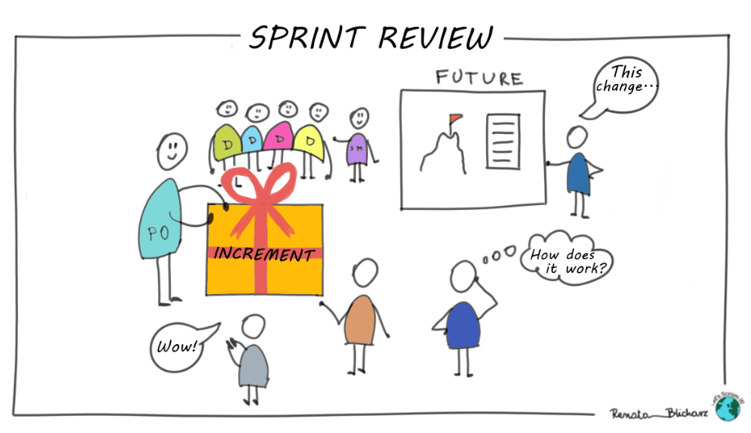

Its purpose is :

1. To know how far we have come.
2. Can we do it or do we need help?

We do a review a previous the retrospeotive.

* Why we need to separate project in to sprint?
* project into sprint is to divide each taste into smaller pieces to make it easier to make.